TCP/IP in-Class Case Studies

- Look at the following output from the ipconfig/all command on your server:
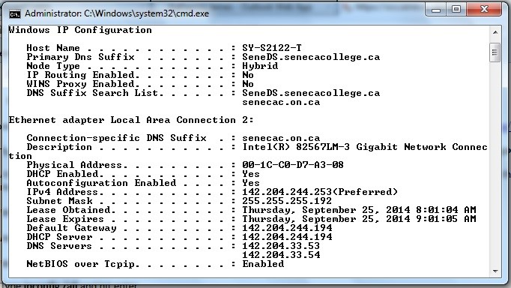
- How can you tell whether the configuration was manual or automatic?
Answer: If IP address, subnet mask. Default gateway and DNS server settings are fully configured with specific values that it is manually set or configured. On the other hand if the settings are to be obtained an IP address or devices support DHCP then it is automatically configured.

- What is the difference between DHCP Enabled and Autoconfiguration Enabled?
Answer: The DHCP Enabled network protocol enables computer to automatically obtain IP address, default gateway, subnet mask and DNS servers from DHCP server on network whereas, Autoconfiguration feature enables computer to automatically configure their IP addresses and subnet mask when they are unable to obtain addresses from DHCP server.

- Is the computer with an IP address of 142.204.1.38 on your Local network, or a remote network? How do you know this?
Answer: By checking local network IP address range. If the IP address 142.204.1.38 falls within the range, then computer is on our my local network.
I can also perform a ping test to see if I can communicate with the machine. If the ping test is successful, it implies that the machine is connected to a distant network or that a firewall is preventing connection.

- What additional device is needed when the host you are connecting to is on a remote network? Does one exist on this server’s network? How do you know?
Answer: The additional device needed when I am connecting to a remote network is a router or gateway device to connect to a host on a remote network because it may forward traffic between local network and the remote network. The router or gateway device routes the traffic between the two networks by serving as a bridge between them.
A device similar to that might exist on the server’s network which is connected to the Internet by a router or gateway device that can send data to other networks, depending on the infrastructure and network configuration. Without more information, it is impossible to say for certain whether a device is linked to the server’s network, but assumptions can be made.
To know whether a router or a gateway device exists on the server’s network I can look network configuration whether a router or gateway device is configured on the network in order to determine whether one is present on the server’s network. If I want to know if there is a route or gateway in place, I can also speak with the network administrator.

- If 142.204.1.38 has a hostname of COMPUTER38, and I use the command ping COMPUTER38, how is that command different from pinging with the IP address only?
Answer: When I ping the hostname “COMPUTER38” my computer must first use Domain Name System (DNS) search to translate the hostname to its matching IP address (142.204.1.38). Once the hostname has been translated into an IP address, the ping command will send request packets to the IP address 142.204.1.38. In short, since both commands ultimately send packets to the same target IP address, the outcomes of pinging hostname “COMPUTER38” and IP address 142.204.1.38 would be similar. However, the hostname can be used instead of the IP address in the ping command. Furthermore, even if the host’s IP address changes, I can still ping it by hostname provided that the DNS records have been updated to reflect the new IP address.

- What if the DNS Server 142.204.33.53 is down?
Answer: If the DNS Server 142.204.33.53 is down devices or software that depend on DNS server may have trouble mapping domain names to their corresponding IP addresses if this DNS server is unavailable. Because of this, users might not be able to access certain network resources, such as websites, email, servers etc.

- Look at the following small office network diagram:
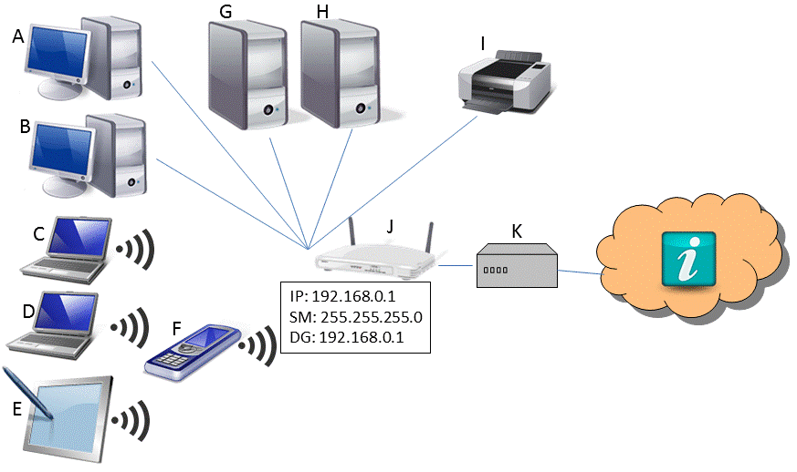

- Describe host J: What kind of device is this? What is its primary purpose on this network? What additional services does it likely provide for this small network?
Answer: This device is Router. The primary purpose of router on a small office network is to link the network to the internet and to make it easier for devices on the local network to communicate with those on other networks, including the internet. Routers provides firewall, Virtual Private Network, DHCP etc.

- How many IP addresses are required for the devices on this small office network?
Answer: The number of devices that will be connected to the network will determine how many IP addresses are needed for a small office network.

- Would you suggest automatic configuration for all devices, or manual configuration of all devices, or a combination? Explain your answer.
Answer: The decision between automatic setup and manual configuration for devices will depend on a number of variables, including the quantity of devices, the complexity of the network and the expertise of the individuals in charge of network management. For smaller networks with fewer devices manual configuration may be a solution. Automatic Configuration can be faster and more efficient option for larger networks.

- Let us assume that we have manually configured our printer with the following:
IP address: 192.168.1.10 Subnet Mask: 255.255.255.0
Will our computers be able to print to the printer? Why or why not?
Answer: Yes, our computer will be able to print to the printer because our IP address is within the range of 192.168.1.1 to 192.168.1.254 with a subnet mask of 255.255.255.0.
- If I used the ipconfig command on SERVER-G, give an example of the information that you might see:
IP address: _192.168.1.10_
Subnet Mask: ___255.255.255.0__
Default Gateway: 192.168.1.1
DNS Server: __192.168.1.5__

- Would it be worthwhile to set up a DNS Server on this network? Why or why not?

Answer: Yes it will be worthwhile to set up a DNS server on this network because it has large number of devices and there was internal servers that needed to be accessed using domain names.

